**EE3TR4 – Lab 3 Report**

**Yiming Chen, 400230266**

**Ruiyi Deng, 400240387**

[cheny466@mcmaster.ca](mailto:cheny466@mcmaster.ca)

[dengr6@mcmaster.ca](mailto:dengr6@mcmaster.ca)

Mar 26th, 2022

1. Simulation Part
2. 图形用户界面, 图表

   描述已自动生成DSB-SC in time domain

图形用户界面

中度可信度描述已自动生成DSB-SC in frequency domain

(ii)

1. 图片包含 图示

   描述已自动生成图表

   描述已自动生成Carrier power is 50% of the total power of the two sidebands
2. 图表, 直方图

   描述已自动生成图表

   描述已自动生成Carrier power is 300% of the total power of the two sidebands
3. 图表, 直方图

   描述已自动生成图表

   描述已自动生成Carrier power is 500% (more than 300%) of the total power of the two sidebands

(iii) Multiply the DSB-SC signal by a LO which is phase synchronized with the carrier. The plot of the signal s’(t) is shown below

(iv) s’(t) pass through an ideal low pass filter which has a cutoff frequency greater than 4 kHz. The plot of the output of the Low Pass Filter is shown below in both time and frequency domain.

1. Experimental Details

Transmit Section:

1. The plot of the DSB-SC signal is shown below from the experiment.

图形用户界面

The two peaks of the frequencies lie at 60 kHz and 68.8kHz respectively.

The experimental result is very close to the simulation result for frequency at 60 kHz and 68.18 kHz respectively. The small discrepancies may come from the inaccurate manipulation when varying PT2 while this error is below tolerance.

1. After varying PT2 the results are shown below with corresponding simulations in matlab.

From the experimental and simulation results we can generally find that the modulated signal has larger amplitude with lower frequency with the increasing carrier signal’s power and the results are corresponding to the simulation result from matlab.

1. To explain how the 4 kHz message signal is generated we shall focus on the board figure given.

The source will generate a 64 kHz message signal and after the /16 part at the board which is shown below

图示

It will have 64/16 = 4 kHz message signal and then going to the OP-AMP for the following operations.

Receive Section:

1. We can see that the time domain waveform of signal we got is similar to the MATLAB simulation result. Noticed that there are some overshoots on the time domain signal, we think that the reason of the overshoot is because of the board noise. For the frequency domain, we zoom in the frequency domain so there are only to main peaks in the picture as we want to show the peak more clearly, but it still matches the simulation result.

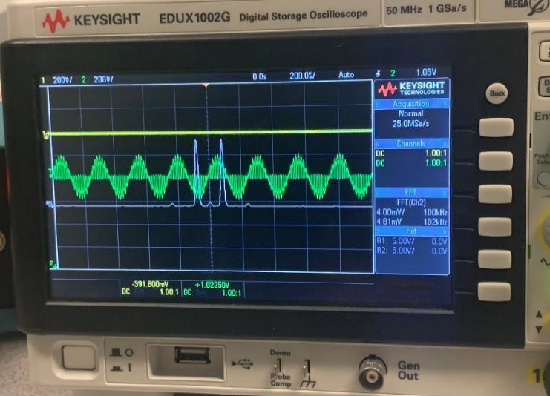

1. The picture shows that the output TP5 signal wave is like a sine wave, which is like our MATLAB result. In addition, we compare the TP5 signal we the original message m(t), they have same frequency, but there has a little phase and amplitude difference.

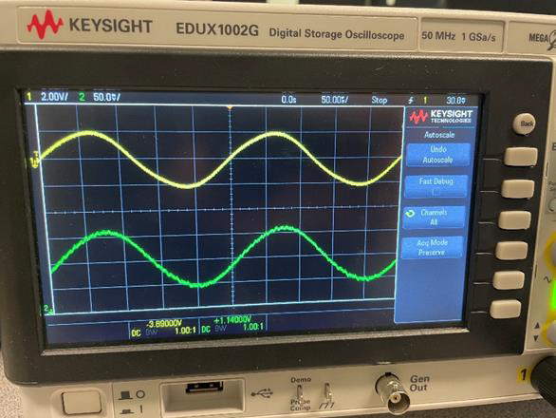

1. From the picture below, by varying PT1, the TP5 signal will change and lose the shape of sine wave, however, the frequency and amplitude doesn’t change. By this, we can confirm that when PT1 changes, the demodulator loses linearity.

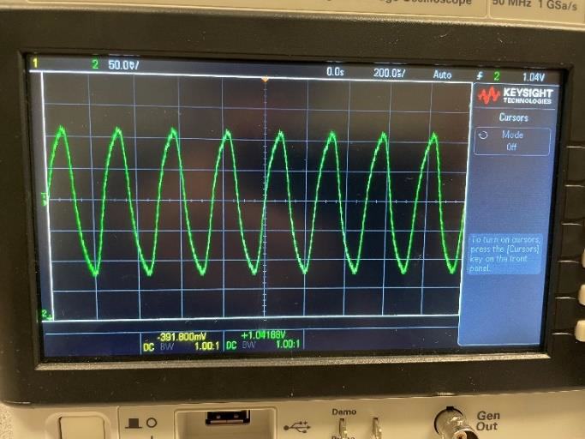

MATLAB Code:

